**Theory of Visual Attention**

# Introduction

This paper examines attention through an experiment in the theory of visual attention (TVA) paradigm (Vangkilde, Bundesen, & Coull, 2011).

The experiment examines which elements in the visual field reaches conscious awareness and the capacity of the visual short term memory (VSTM) – in short, how many resources are available and how they are distributed. Spatial distribution of attention and selection between relevant and irrelevant elements are also examined. Through the mathematical models of TVA measures of processing speed (*C*), VSTM capacity (*K*), selectivity between relevant and irrelevant elements ($α$), the perceptual threshold in milliseconds (*t0*) and lateral attention weight (*Windex)* will also be investigated.

In accordance with other TVA paradigm experiments, results for this experiment are expected to show an increase in correctly reported letters as RT increases and a correlation between TVA parameters *C* and *K.* It is further expected that distractors in *partial report* trials will decrease the number of correctly reported letters and that participants will show a laterally balanced attentional weighting of stimuli. Men and women are expected to display similar performances while age is expected to correlate with most or all TVA parameters (Habekost, 2015).

# Method

This experiment included *N* = 207 participants, 37 male, 169 female, all psychology students at UCPH. Age differences were not considered.

## Materials

* Computer with CombiTVA programme

## Procedure

This computer-based experiment combines two classical paradigms for studying attention, *whole report* and *partial report*. Participants, are instructed to report either red or blue letters, ignoring the opposite. They are then presented with a fixation cross for 1000ms, before a display of six letters appear. This display is exposed for 10-200ms depending on test condition. All letters are then masked for 500ms, before participants are asked to report as many letters in the target colour as possible. For *whole report* conditions, all letters are the target colour, while *partial report* conditions include distractors of the other colour. The experiment is conducted in nine blocks of 27 trials.

# Results

Figure 1 displays the number of correctly reported letters for various display conditions. There is a clear trend towards more letters reported as display time increases. Further, participants, on average, report more than half of the two possible letters correctly in the two-targets-four-distractors displays, implying that their attentional selectivity ($α$) is good yet imperfect. This display type, which has an exposure time of 150ms, shows a markedly lower number of correctly reported letters than for the same exposure time without distractors, suggesting that distractors influence perception.

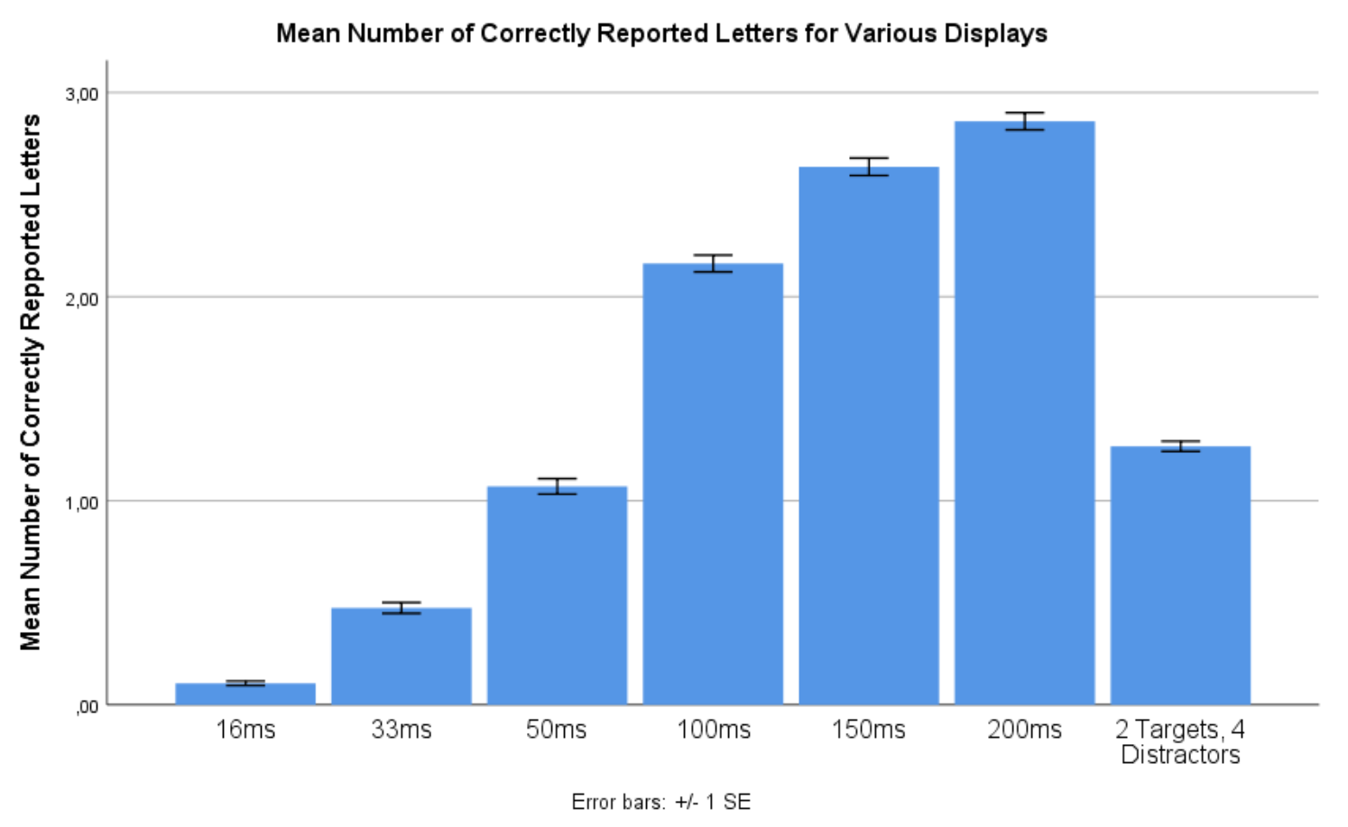

Figure 1: Letters correctly reported

To further investigate these observations, a repeated measures ANOVA of effect of display time on number of correctly reported letters was conducted.

The test showed a significant main effect of display time on number of correctly identified letters, *F*(2.00, 411.36) = 3018.09, *p* < .001, $η_{p}^{2}$ = .94 (Huyhn-Feldt corrected), confirming the observed effect of display time from Figure 1.

Figure 2: TVA plot for FP19201

Figure 2 is an example of a TVA plot, from which one can estimate *K, C,* and *t0.* FP19201 also reports more letters as exposure time increases.

## Capacity and processing speed correlate

Habekost (2015) argues that *C* and *K* are often positively correlated. To test whether this was replicated in these findings, a two-tailed Pearson’s correlations test was run showing a significant positive correlation between *C* and *K*, *r*(205) = .47, *p* < .001. Age was positively correlated with $α$, *r*(205) = .18, *p* = .01. However, age did not correlate with any of the other TVA parameters or with error-rate, *r*s ≤ .13, dfs = 205, *p*s ≥ .07.

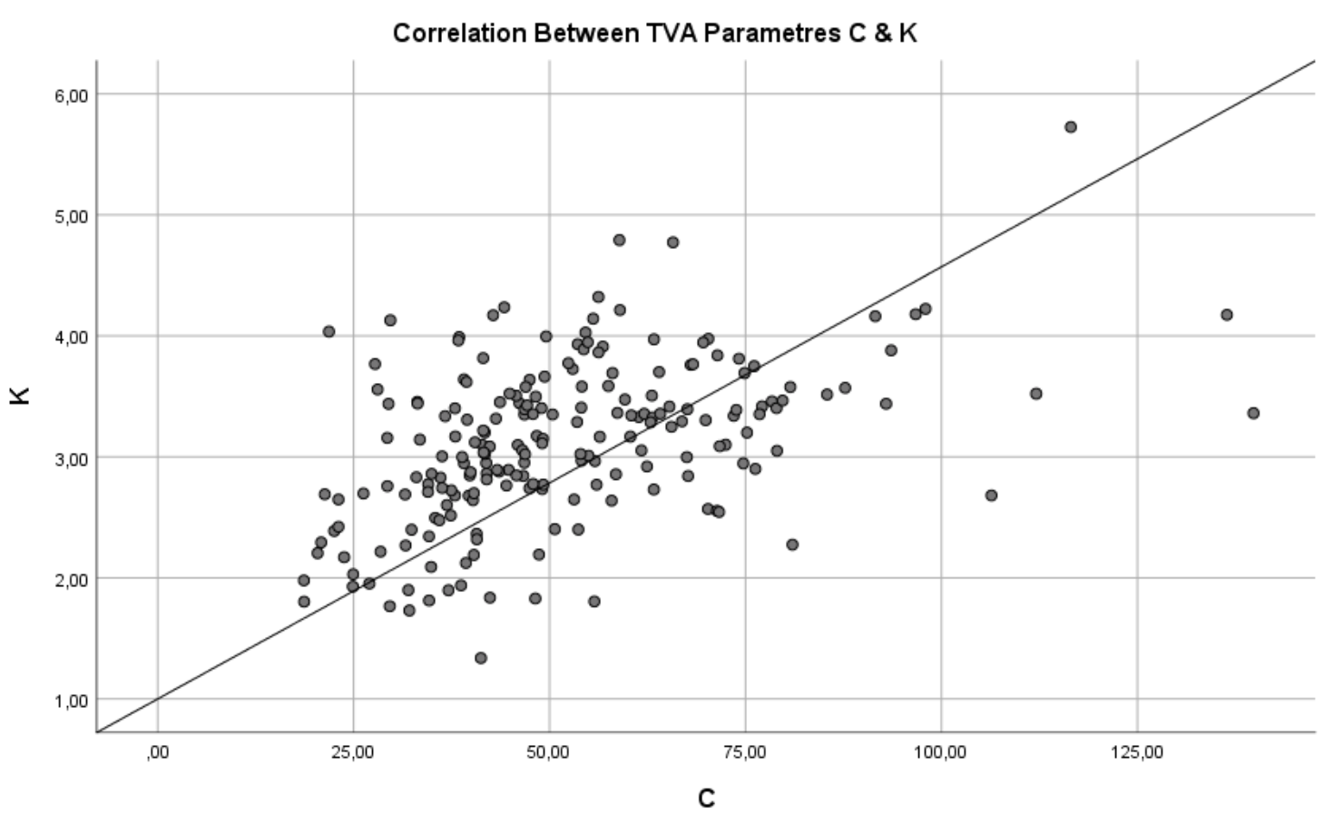 Figure 3: Correlations between C and K

As parameters within the TVA model are independent, they ought not correlate. This correlation, however, may be explained by alleging that there be overlapping neural bases for the two factors (Habekost, 2015).

Also of interest is the effect of age. Its correlation with $α$ is significant, yet the typical correlations with other TVA factors were not found, though this may be due to the rather narrow age spread in the sample.

Figure 3 graphically displays the correlation between *C* and *K* indicating that processing speed of and capacity for visual stimuli are related.

## Attentional weight and sex differences

To examine sex differences in visual attention, independent samples *t*-tests were conducted for each test parameter. Results are displayed in Table 1 along with estimates for all TVA parameters.

|  |  |  |  |  |  |  |  |  |  |
| --- | --- | --- | --- | --- | --- | --- | --- | --- | --- |
| Table 1 *Mean* *TVA estimates and error rates distributed across sex with relevant t-tests* | | | | | | | | | |
|  | Female (*N* = 169) | |  | Male (*N* = 37) | |  | *t*-tests | | |
|  | *M* | *SD* |  | *M* | *SD* |  | *t*(204) | *p* | *d* |
| *t*0 | 18.55 | (9.20) |  | 16.49 | (8.26) |  | 1.25 | .21 | 0.24 |
| *C* | 51.47 | (19.62) |  | 52.61 | (22.21) |  | -0.31 | .76 | -0.05 |
| *K* | 3.10 | (0.65) |  | 3.18 | (0.68) |  | -0.71 | .48 | -0.13 |
| . $α$ | 0.40 | (0.31) |  | 0.35 | (0.36) |  | 0.89 | .38 | 0.15 |
| *windex* | 0.54 | (0.10) |  | 0.50 | (0.10) |  | 2.23 | .03 | 0.41 |
| Error rate | 0.15 | (0.07) |  | 0.16 | (0.07) |  | -0.51 | .61 | -0.09 |
| *Note*. Units: *t*0 (ms), *C* (letters/second), K (letters), *α* runs from perfect selectivity at 0.0 to no selectivity at 1.0, *w*index (< 0.5 = right side weighting, > 0.5 = left side weighting). | | | | | | | | | |

Only one significant difference between males and females were found, namely the *Windex* factor which indicates that males split their attention evenly while females slightly weighted their attention left of the fixation cross. Considering the rather small sample of males, however, these findings are hardly conclusive.

To test for attentional preferences towards the left or right side of the display, a one-sample *t*-test of difference between Windex and 0.5 (balanced attentional weighting) was conducted.

The test (two-tailed, alpha = .05) showed a significant difference of windex from 0.50, *t*(206) = 5.33, *p* < .001, *d* = 0.37, indicating that participants do not split their attention evenly between the left and right sides of the display, but rather prioritised stimuli left of the fixation cross.

## Imperfect selectivity

To examine the effect of distractors a one-sample *t-*test of difference between mean number of correctly reported letters for two-target-four-distractor displays and 2 (maximum possible correctly reported letters) was conducted.

The test (two-tailed, alpha = .05) showed a significant difference between correctly reported letters for two-target-four-distractor displays and 2, *t*(206) = -29,47, *p* < .001, *d* = -2.05, confirming that selection is imperfect.

This means that, while there is some selection, monitored by top-down processes, bottom-up processes interfere and inject distractors into conscious awareness, bypassing the attempt at attentional control.

# Conclusion

These findings support the hypotheses that more letters are correctly reported when exposure time increases, that distractors reduce accuracy in *partial report* trials, and that *C* and *K* are significantly correlated. The results do not, however, support the hypothesis that attention is divided equally between the left and right sides of the display.

# References

Habekost, T. (2015). Clinical TVA-based studies: a general review. *Frontiers in Psychology*, *6:290*, 1–18.

Vangkilde, S., Bundesen, C., & Coull, J. T. (2011). Prompt but inefficient: nicotine differentially modulates discrete components of attention. *Psychopharmacology*, *218*, 667–680.